Dabbaman

Tiffin Management System

Introduction:

The primary objective of the system is to demonstrate CRUD operations using Spring Boot Framework.

Dabbaman facilitates the user to search for the tiffin providers in his/her vicinity and order a customized menu for his/her tiffin.

The system allows the user to order the tiffin from the localities where the tiffin providers are registered. The user can then opt either for a Half Meal or a Full Meal.

Based on the type of the meal, the user gets to customize the menu from the provided choices.

System Study:

This project is based on the MVC model. The “IndexController” class acts as the controller for this project and controls the flow of the project.

The “Repositories” classes contains the CRUD methods for the entity classes.

The entity classes present in the model package describes the table structure and relation between them.

The html files present in the template folder along with the static folder forms the view part of the MVC model.

Technologies Used:

* HTML 5
* CSS 3
* Bootstrap 4
* JavaScript
* Maven
* Spring Boot
* Oracle
* Hibernate

UML Diagrams:

1. ER Diagram

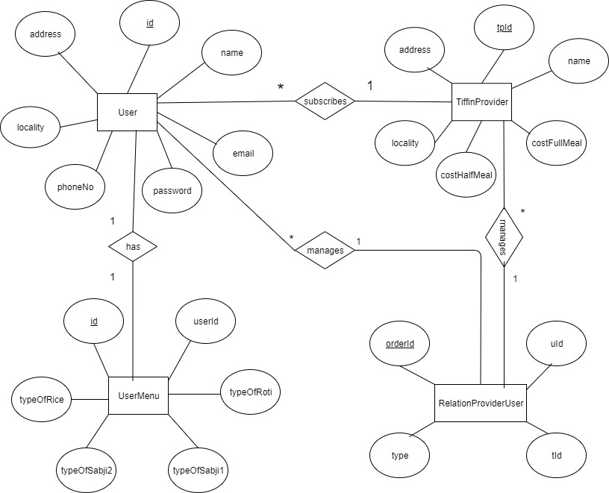

Fig: ER diagram

1. Class Diagram

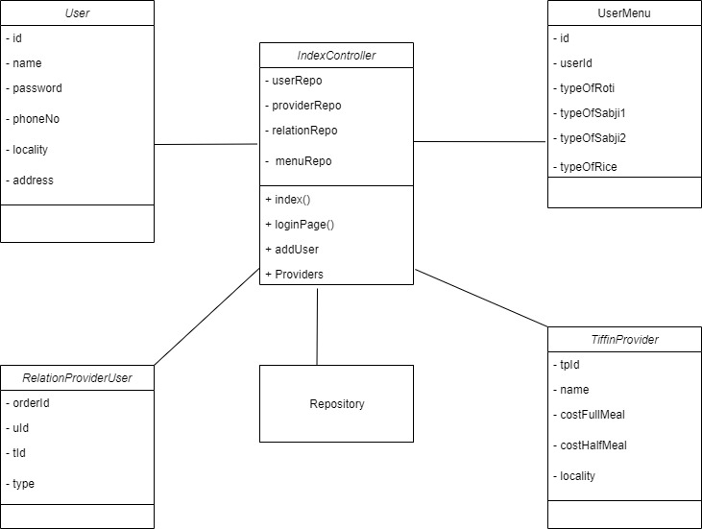

Fig: Class Diagram

Screenshots:

